1. List the name of the managers with the maximum employees

select ename from employee

where mgr_no =(select max(mgr_no) from employee);

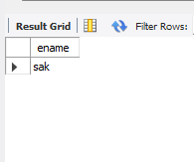

2. Display those managers name whose salary is more than average salary of his

employee.

select ename from employee

where sal>(select avg(sal) from employee);

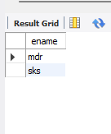

3. Find the name of the second top level managers of each department.

select ename from employee

where sal=(select max(sal) from employee

where sal<(select max(sal) from employee));

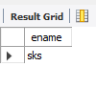

4. Find the employee details who got second maximum incentive in January 2019.

select * from employee

where empno =(select empno from incentives

where amt = (select max(amt) from incentives

where amt<(select max(amt) from incentives)));

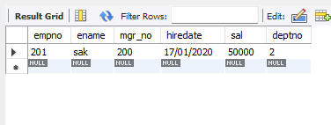

5. Display those employees who are working in the same department where his

manager is working.

SELECT e1.empno AS EmployeeID, e1.ename AS EmployeeName, e1.empno AS EmployeeDeptNo,

e1.mgr_no AS ManagerID, e2.empno AS ManagerDeptNo

FROM employee e1

LEFT JOIN employee e2 ON e1.mgr_no = e2.empno;

